**5,068 SF**

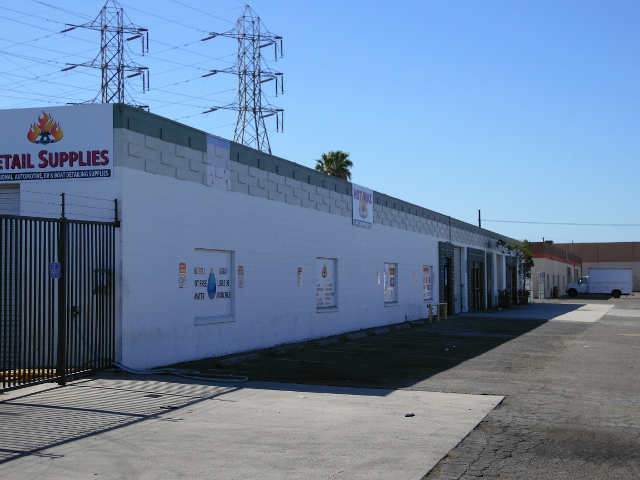

**5,068 SF Industrial Space**

**3,100 SF Fenced Yard Space**

|  |
| --- |
|  |

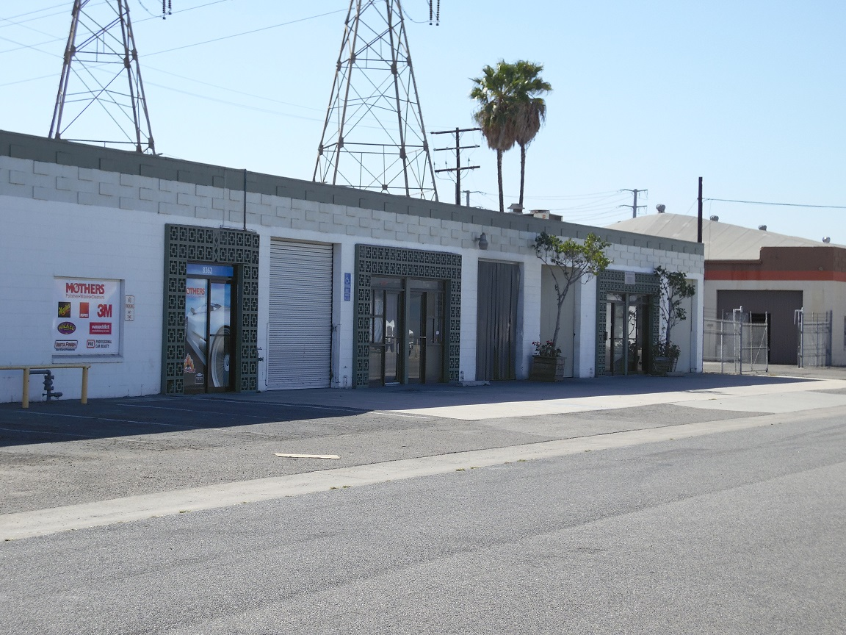

Building Area 5,068 sq. ft.

Yard Area 3,100 sq. ft.

Truck Access 10’x12’ grade level door

Ceiling Height 14 feet to 16 feet

Eleven (9) Parking Spaces

Electrical Power 200 Amp - 120 volt panel

**Lease Rate:**

**$6,842.00 per Month + electric, water/sewer and trash**

